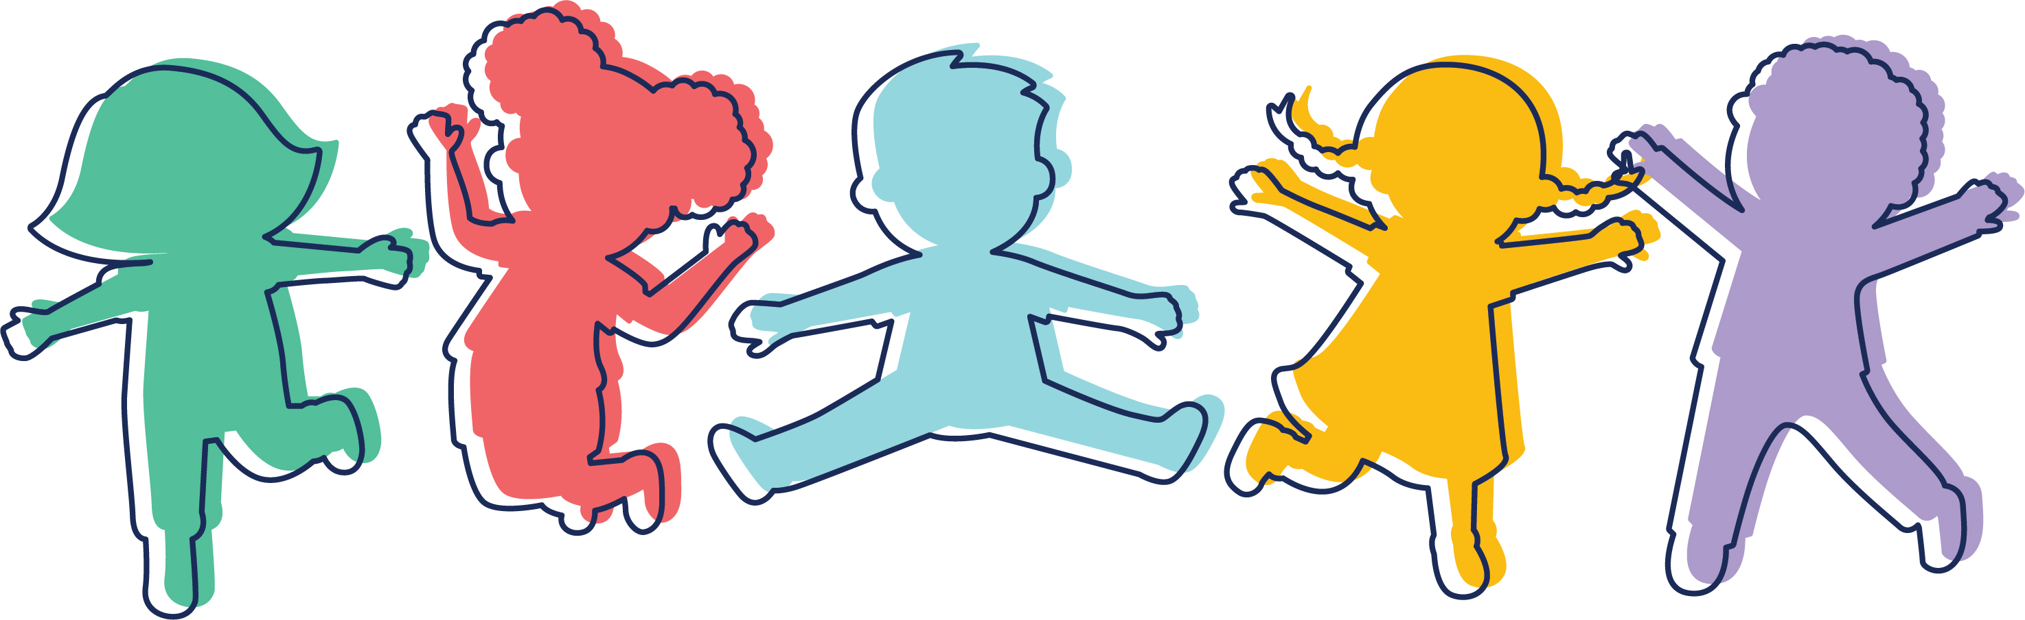
CLARA BARTON CENTER FOR CHILDREN
7425 MacArthur Boulevard • Cabin John, MD 20818
(301) 320-4565 www.clarabartoncenter.org

2025 SUMMER CAMP APPLICATION

Child’s Name: Birth Date: ____/____/____ Sex: M F
(Last) (First)

Home Address:
(Street) (City) (State) (Zip Code)

Name of Parent/Guardian: (1)

Home Phone: (____)__________________ Work Phone: (____)_________________ Cell Phone: (____)_________________

Name of Parent/Guardian: (2)

Home Phone: (____)__________________ Work Phone: (____)_________________ Cell Phone: (____)_________________

E-mail Address(es): ___________________________________________________________________________________________________________________

- To register, a non-refundable deposit of $250 must accompany each application. (Make check payable to “Clara Barton Center for Children.”) This deposit will be applied to summer camp tuition.

- Priority for enrollment will be given to children currently enrolled at CBCC only until February 3, 2025.

- Clara Barton Summer Camp reserves the right to cancel any class for lack of enrollments. In this event, tuition paid will be refunded.

- Withdrawals must be submitted in writing by March 21, 2025, in order to receive a refund of tuition paid, less the $250 non-refundable deposit. There will be no refunds of tuition made after March 21, 2025.

- By February 14, 2025, 50% of the total summer camp tuition must be paid or your child’s space may be forfeited; bills will be emailed.

- The balance of summer camp tuition is due on May 9, 2025.

- You must enroll your child for the entire session.

- Campers in the Puffins, Cardinals, and Eagles classes (i.e., 3 ½ years and older) must be fully toilet-trained to attend camp.

- All Campers attend 5 days per week.

- You may not request different dismissal times within a session.

- A child must be at least two years old by May 31, 2025, in order to attend summer camp.

- The majority of our regular classroom teachers take their vacations during the summer months, so your child may not have the teacher who teaches in a particular classroom during the school year as his or her summer camp teacher. Also, although we strive to maintain teaching team consistency throughout the summer for each class group, your child may not have the same teachers for each session. (over)

Please indicate below the sessions and dismissal time you are requesting.
We are unable to accommodate different dismissal times within a session

_____ Session 1: “Architects & Builders” June 23 – July 3, 2025* (2 weeks)
[*Camp CLOSED on Friday, July 4 in observance of Independence Day]

Half Day: ______ Extended Day: ______ Full Day: ______
(8:00 a.m.-12:20/12:30 p.m.) (8:00 a.m.-3:30 p.m.) (8:00 a.m.-6:00 p.m.)

_____ Session 2: “Let’s Go Camping!” July 7 – July 18, 2025 (2 weeks)

Half Day: ______ Extended Day: ______ Full Day: ______
(8:00 a.m.-12:20/12:30 p.m.) (8:00 a.m.-3:30 p.m.) (8:00 a.m.-6:00 p.m.)

_____ Session 3: “Young Chefs” July 21 – August 1, 2025 (2 weeks)

Half Day: ______ Extended Day: ______ Full Day: ______
(8:00 a.m.-12:20/12:30 p.m.) (8:00 a.m.-3:30 p.m.) (8:00 a.m.-6:00 p.m.)

_____ Session 4: “Down by the Bay” August 4 – August 15, 2025** (2 weeks)

Half Day: ______ Extended Day: ______ Full Day: ______
(8:00 a.m.-12:30 p.m.) (8:00 a.m.-3:30 p.m.) (8:00 a.m.-6:00 p.m.)
[**Camp CLOSES at 12:30 on Fri., August 15]

I agree that this application serves as a binding agreement with the Clara Barton Center for Children Summer Camp. I have read the brochure and give my child permission to attend summer camp. The information I have provided is accurate to the best of my knowledge. If my child is a Puffin, Cardinal or Eagle, I agree that my child must be fully toilet trained to enroll in CBCC camp. I am enclosing a non-refundable deposit of $250 to reserve my child’s space in camp. I agree to pay 50% of tuition due by February 14, 2025 and understand that my child’s space may be forfeited for non-payment. I agree to pay the remaining balance of summer camp tuition by May 9, 2025. I understand that any request for withdrawal must be made in writing by March 22, 2025, in order to receive a refund of tuition paid less the non-refundable deposit, and that there will be no refunds of tuition made after March 21, 2025. Further, I understand that I may enter into a payment plan with the Clara Barton Center for Children to pay summer camp tuition, and it is my responsibility to contact Deborah Duffy, Assistant Director (301-320-4565 or deborah.duffy@clarabartoncenter.org) to arrange the details of the plan. The Clara Barton Center for Children has permission to publish and/or print and/or electronic/video format a likeness/image of my child for program advertising purposes only.

Parent/Guardian Signature Date

For Office Use Only:
Date Received________________ Deposit Amt. ________________ Check #______________ Class________________________

